PIZZA SALES SQL QUERIES

A.KPI’S

1.Total Revenue

SELECT SUM(total_price)as Total_revenue from pizza_sales;



2.Average order value

SELECT SUM(total_price)/ COUNT(DISTINCT order_id) as Average_order_value from pizza_sales

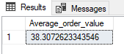

3.Total pizzas sold

select SUM(quantity) as Total_pizzas_sold from pizza_sales

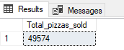

4. Total orders

SELECT COUNT(DISTINCT order_id) as Total_orders from pizza_sales



5. Average pizzas per order

SELECT CAST(CAST(SUM(quantity) AS DECIMAL(10,2))/

CAST(COUNT(DISTINCT order_id)AS DECIMAL (10,2)) AS DECIMAL(10,2)) from pizza_sales

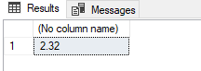

B. CHART REQUIREMENTS

1.Daily trend

SELECT DATENAME(DW, order_date) as order_day, COUNT(DISTINCT order_id) as Total_orders from pizza_sales

GROUP BY DATENAME(DW, order_date)

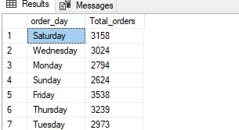

2. Monthly trend for total orders

SELECT DATENAME(MONTH, order_date) as Monthly_name, COUNT(DISTINCT order_id)as Total_orders from pizza_sales

GROUP BY DATENAME(MONTH, order_date)

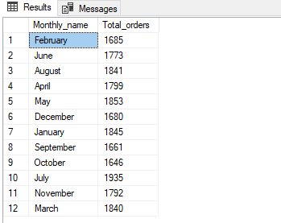

3. Percentage of sales by pizza category

SELECT pizza_category,SUM(total_price)*100/ (SELECT SUM(total_price) from pizza_sales) as precentage_Total_sales from pizza_sales

GROUP BY pizza_category

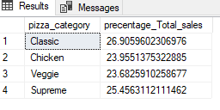

4. Percentage of sales by pizza size

SELECT pizza_size,SUM(total_price)*100/ (SELECT SUM(total_price) from pizza_sales) as percentage_Total_sales from pizza_sales

GROUP BY pizza_size

ORDER BY percentage_Total_sales

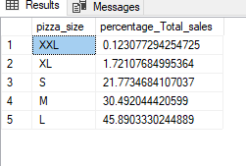

5.Top 5 best sellers by revenue

SELECT TOP 5 pizza_name, SUM(total_price)as total_revenue from pizza_sales

GROUP BY pizza_name

ORDER BY total_revenue DESC

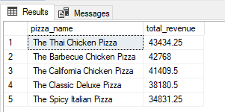

6. Bottom 5 worst sellers by revenue

SELECT TOP 5 pizza_name, SUM(total_price)as total_revenue from pizza_sales

GROUP BY pizza_name

ORDER BY total_revenue

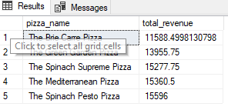

7. Top 5 best sellers by quantity

SELECT TOP 5 pizza_name, SUM(quantity)as total_quantity from pizza_sales

GROUP BY pizza_name

ORDER BY total_quantity DESC

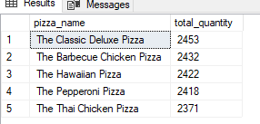

8. bottom 5 sellers by quantity

SELECT TOP 5 pizza_name, SUM(quantity)as total_quantity from pizza_sales

GROUP BY pizza_name

ORDER BY total_quantity

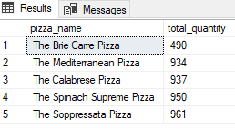

9. Top 5 by orders

SELECT TOP 5 pizza_name, COUNT(DISTINCT order_id)as total_orders from pizza_sales

GROUP BY pizza_name

ORDER BY total_orders DESC

